WeSmellBetter.com Report – Region 4 Starters & Average Pass Rate, 2025 and All Years
Following is my initial attempt at summarizing data for pass rates by state, using the states in AKC Scent Work Region 4. There is information for 2025 and then “the sport up to January 24, 2026” for each class by state, and then for each level.
When this analysis was requested, I suspect competitors were looking for information to support the idea that pass rates in their area were generally lower than in other parts of the country – that, at least some of the time, the deck was stacked against them before they crossed the start line. In Region 4, I’m not seeing anything that points definitively in that direction. I have included the number of “starters” that the AKC reported for each class because if there are variations in pass rates, it seems to me that those could easily be the result of a smaller sample.
Texas certainly dominates in number of starters, but the qualifying rates seem pretty darned similar across the 14 states in the Region. Things get a little wonky in the upper levels, but, again, that seems to often be the result of having only a very small number of competitors. Oklahoma, you definitely deserve a call-out for your work in Handler Discrimination, though – way to go!
As before, the data I used here is from the WeSmellBetter “Qualifiers By Class” summary report that is available to anybody, any time. The Coder is busy doing other things and I didn’t want to bother him for custom queries, so I just copied that data and pasted it into Excel, one tab per state showing Starters and Average Pass Rates for each class for 2025 and for “everything up to January 26.” If you want to play with that data, I’m happy to share that Excel spreadsheet with you with the caveat that it was a lot of copying and pasting and I got bored, so Beware and Double Check Everything.
In fact, “Double Check Everything” is good advice. I’m not a professional, don’t even play one on TV, so before you get excited about anything you see, let’s make sure I didn’t do something stupid with the data.
What do you see – anything to get excited about in Region 4?
--Kristi (wesmellbetter@gmail.com)
 | 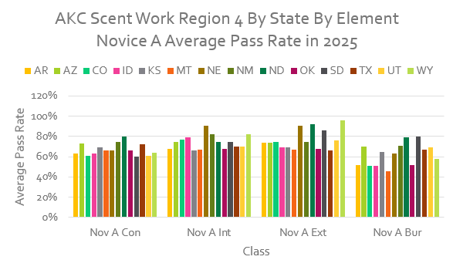
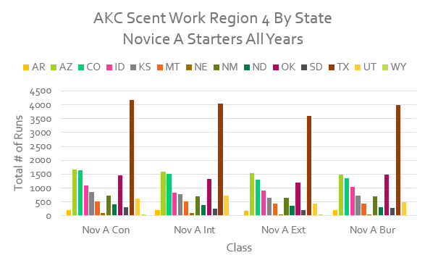 | 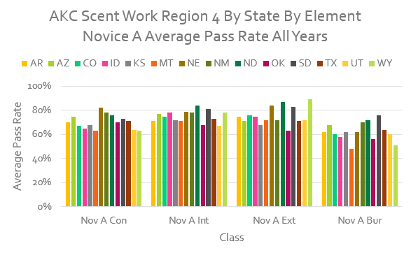

AKC Scent Work Starters and Average Pass Rates for the Novice A Class, By Element, By State for Region 4

2025 & All Years (up to January 24, 2026)

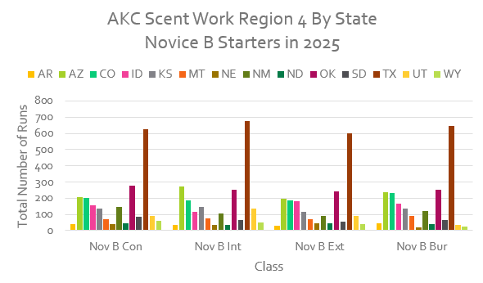 | 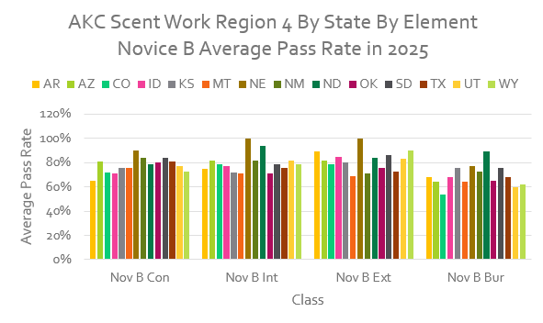
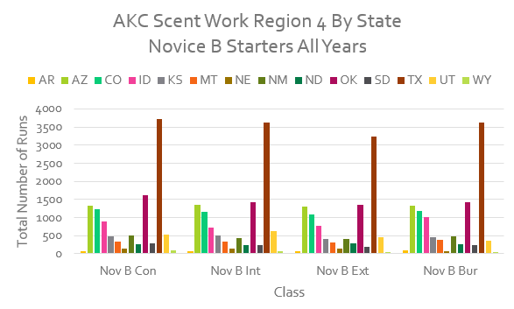 | 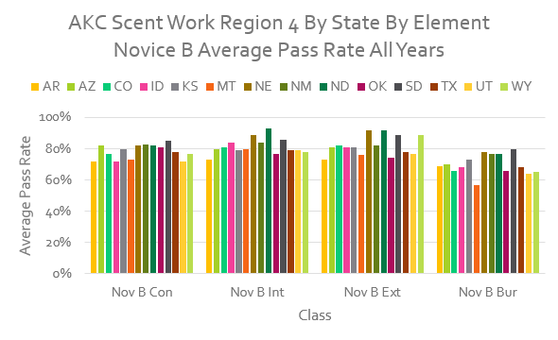

AKC Scent Work Starters and Average Pass Rates for the Novice B Class, By Element, By State for Region 4

2025 & All Years (up to January 24, 2026)

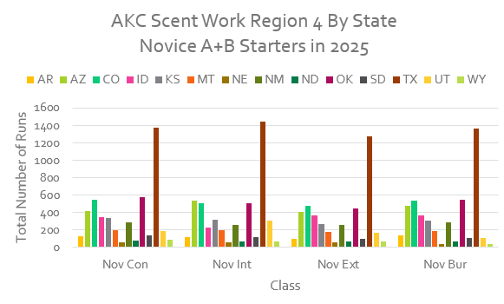 | 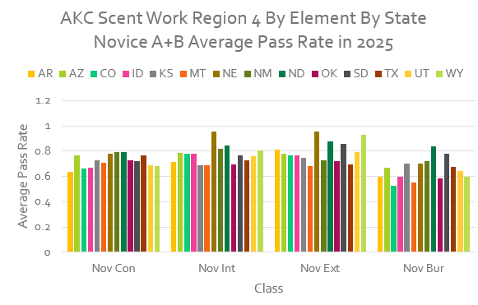
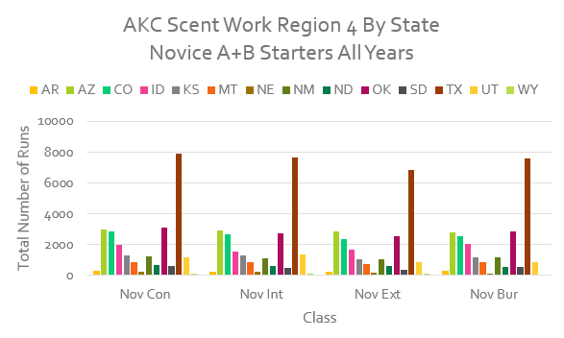 | 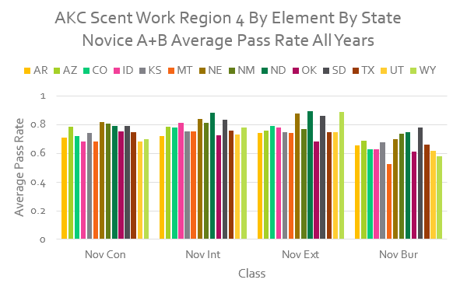

AKC Scent Work Starters and Average Pass Rates for the Combined Novice A & B Classes, By Element, By State for Region 4

2025 & All Years (up to January 24, 2026)

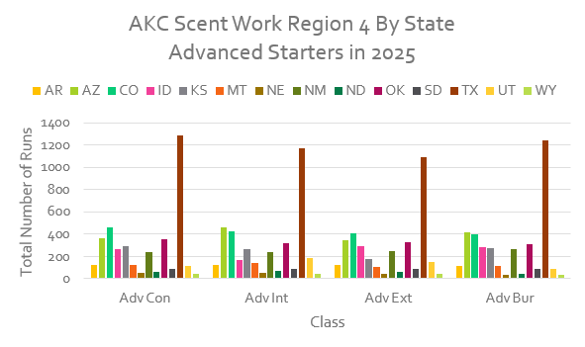 | 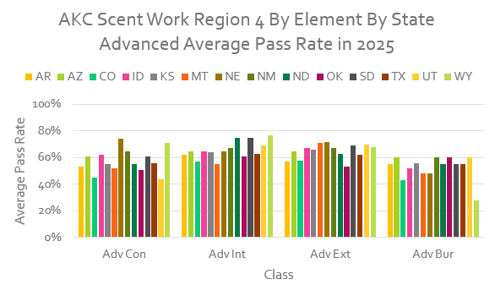
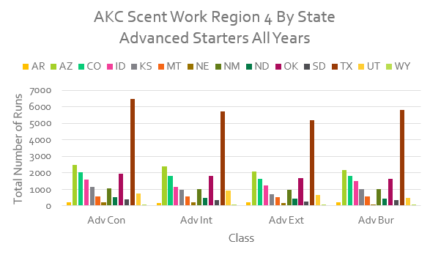 | 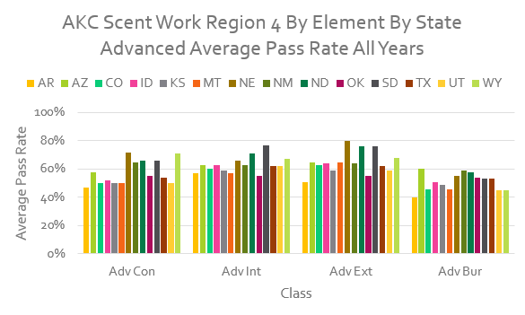

AKC Scent Work Starters and Average Pass Rates for the Advanced Classes, By Element, By State for Region 4

2025 & All Years (up to January 24, 2026)

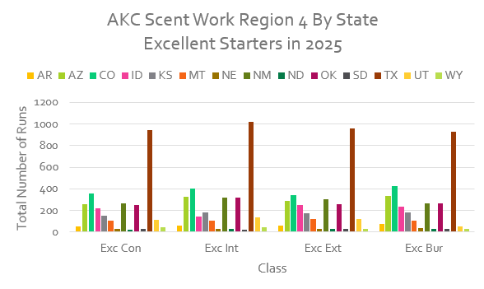 | 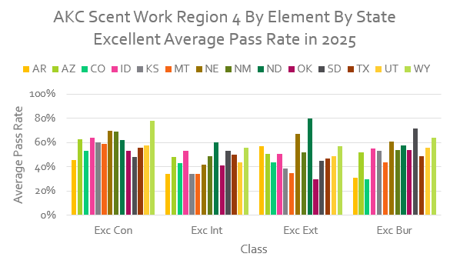
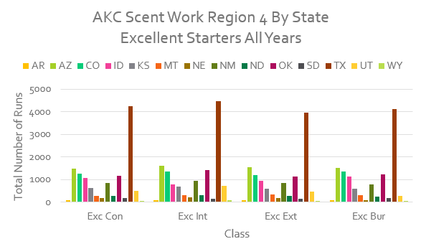 | 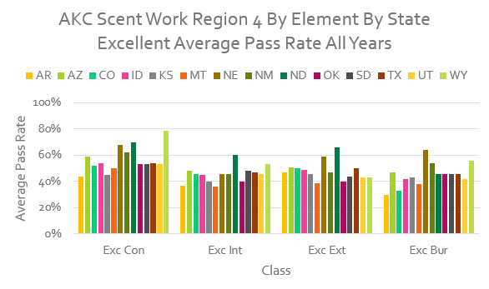

AKC Scent Work Starters and Average Pass Rates for the Excellent Classes, By Element, By State for Region 4

2025 & All Years (up to January 24, 2026)

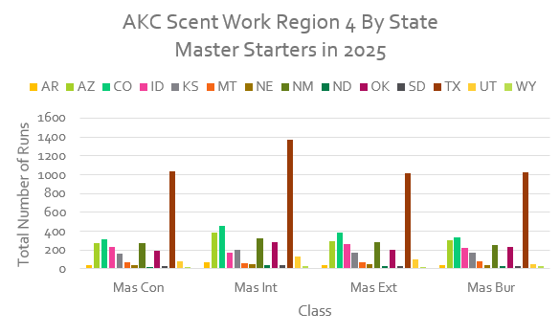 | 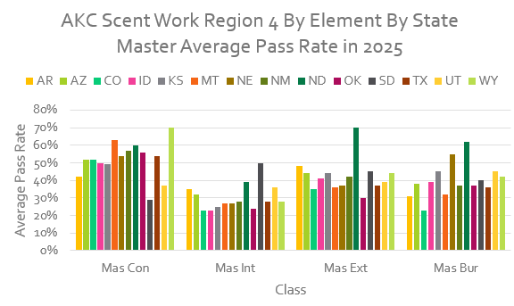
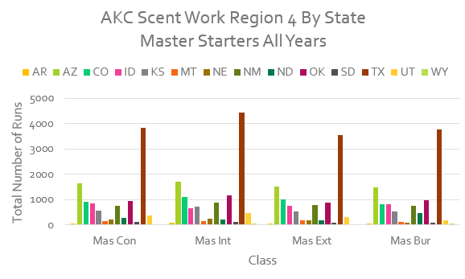 | 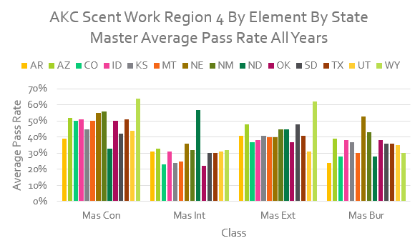

AKC Scent Work Starters and Average Pass Rates for the Master Classes, By Element, By State for Region 4

2025 & All Years (up to January 24, 2026)

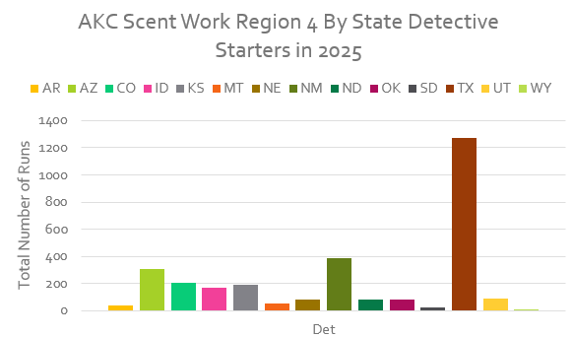 | 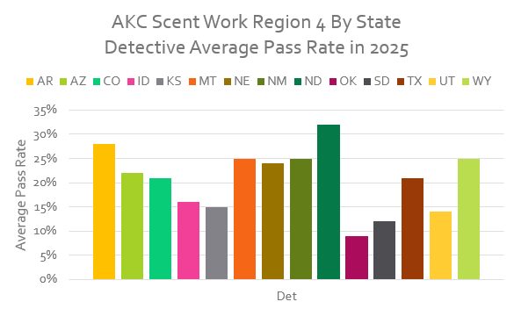
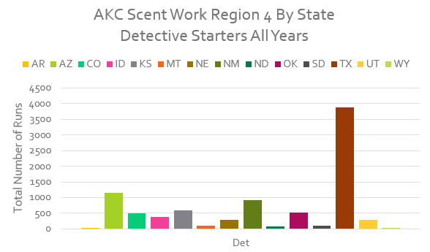 | 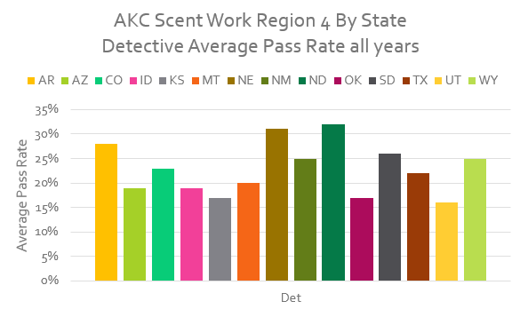

AKC Scent Work Starters and Average Pass Rates for Detective, By State for Region 4

2025 & All Years (up to January 24, 2026)

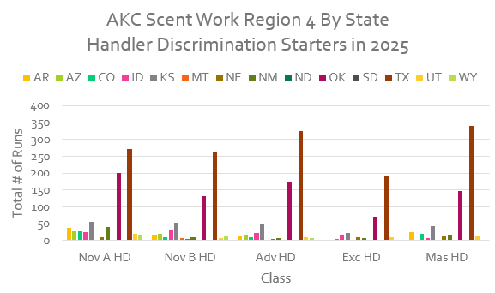 | 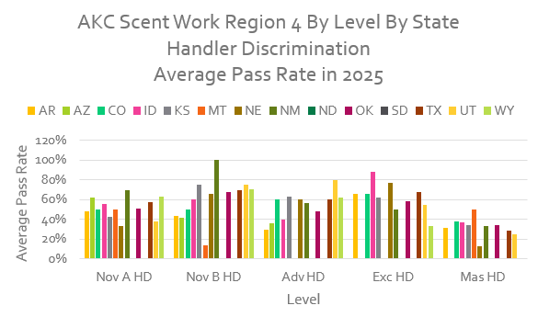
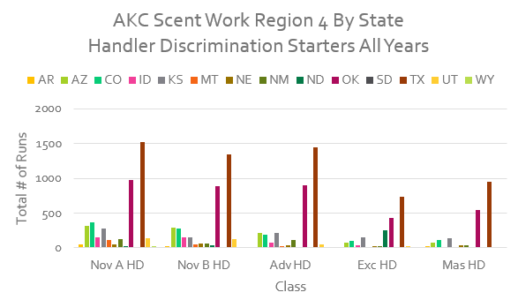 | 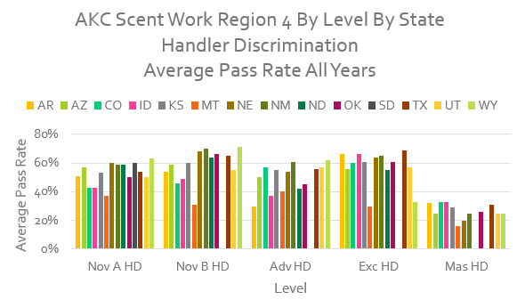

AKC Scent Work Starters and Average Pass Rates for Handler Discrimination, All Levels, By State for Region 4

2025 & All Years (up to January 24, 2026)

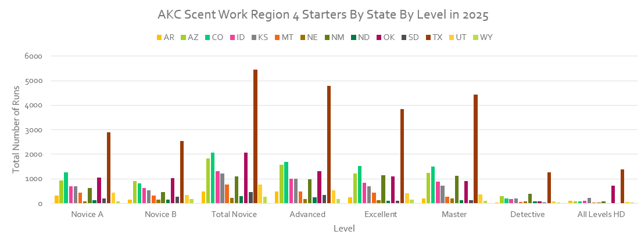
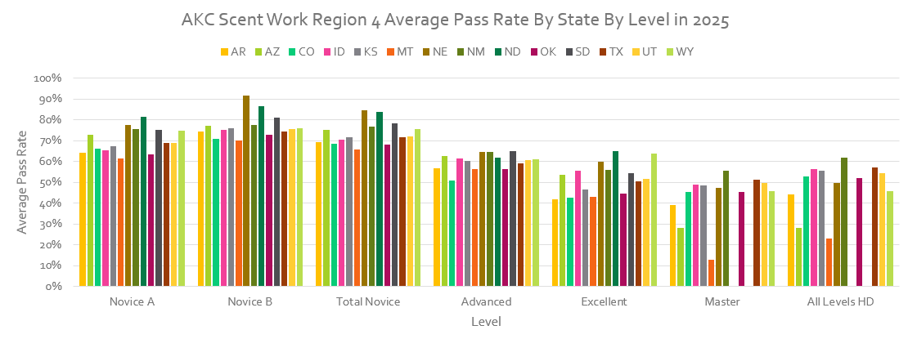

AKC Scent Work Starters and Average Pass Rates for Each Level, By State for Region 4

2025

Note that these numbers are accumulated “in general” and do not correlate to titles which reflect the overall accomplishment of a single dog at a level, i.e. “a Q is just a Q.”
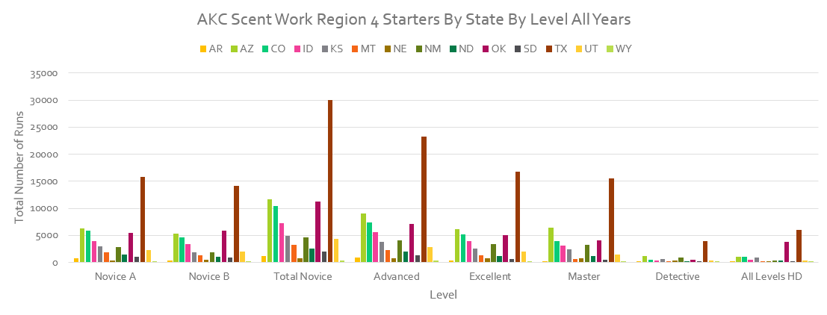
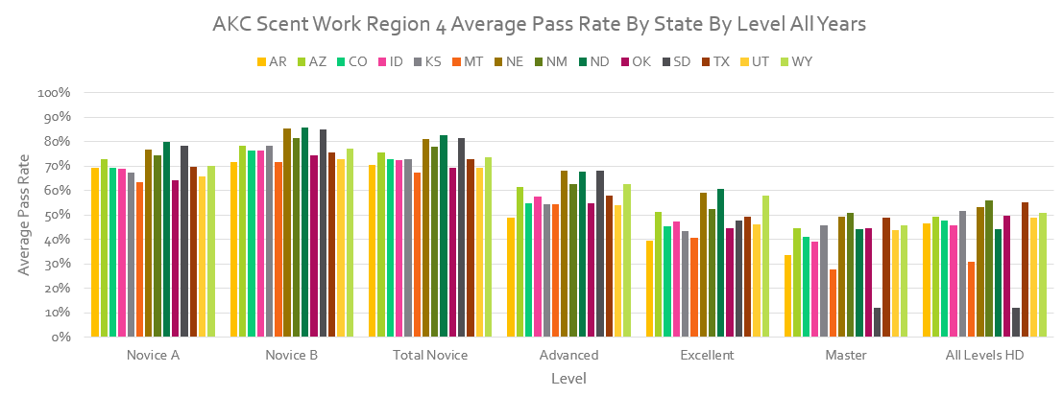

AKC Scent Work Starters and Average Pass Rates for Each Level, By State for Region 4

All Years (up to January 24, 2026)

Note that these numbers are accumulated “in general” and do not correlate to titles which reflect the overall accomplishment of a single dog at a level, i.e. “a Q is just a Q.”

